UR PERCENTILE
Visit : http://groups.yahoo.com/group/urpercentile/
Preparing for entrance exam for top Management Institute ?
Join Us.

LESSON P1048 Time Limit : 20 Minutes
http://groups.yahoo.com/group/urpercentile/

Q1 to Q6 are based on the following graphs
One of the graph below represent the market share of five different brands of T.V sold in a particular city. The total number of TV sold was 25,000.
The other one shows the unit sales price and the Tax the brand is subjected to. Tax is calculated on the sales price.

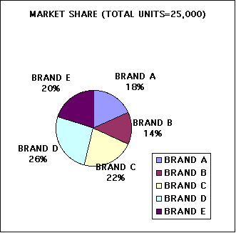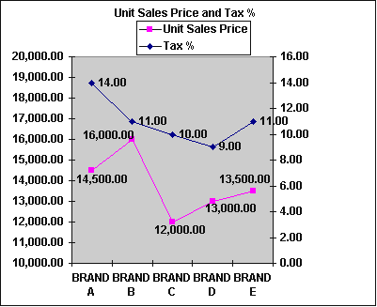

Q1. What is the difference in number of units sold by the most popular brand and the second most popular brand ?
Q2. Which Brand earned the maximum revenue before Tax ?
Q3. Which Brand earned the maximum revenue after Tax ?
Q4. Which Brand had to pay the Maximum Tax ?
Q5. The number of units sold of Brand A increased by 900 units in the next year, but the Market share of each Brand including Brand A remained the same. What would be the new total number of units sold.
Q6. Which one of the following is true :
a) The Brand which sold the maximum number of units paid the maximum Tax
b) The Brand with highest unit cost paid the maximum Tax
c) The brand with highest sales revenue before tax paid the maximum tax.
d) The brand with highest Tax % paid the maximum Tax.

Q7 to Q12 are based on the following graph.
The graph represent the Speed and the time traveled by 6 buses. The speed is given in Meters / Minute and the time is given in minutes.
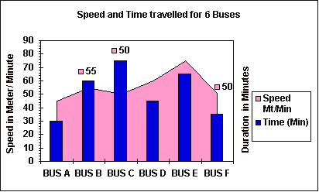

Q8. Which Bus traveled the minimum distance ?
Q9. If a driver travels more than 3.5 Km with a average speed of more than 48 Mt/ Sec, he has to pay a penalty. How many drivers have to pay penalty?
Q10. If all of the buses start at the same time , which bus will reach its destination first ?
Q11. Which one of the following is true :
a) The Bus with Minimum speed traveled 2 Km less than the one with the highest speed.
b) There are 2 buses that traveled more than 4 Km.
c) There are two buses that traveled less than 2 Km.
d) Both b and c .
Q12. Bus A and F charge Rs. 10 for each passenger , Bus D charges Rs 15 per passenger and the remaining buses charge Rs. 20 for each passenger. Which bus charges the minimum for each Km traveled?

Q13 to Q 18 are based on the following Table providing information about 2 trains running between Dehradun and Delhi.
 | Arrival / Departure TIME-Train 1 | Arrival / Departure TIME-Train 2 | DISTANCE FROM DEHRADUN (Km)
DEHRADUN (Dep) | 17:00 | 09:05 | 0
HARIDWAR (Arr) | 18:05 | 10:15 | 52
HARIDWAR (D) | 18:10 | 10:24 | 52
ROORKEE (A) | 18:48 | 11:10 | 98
ROORKEE (D) | 18:50 | 11:14 | 98
SAHARANPUR (A) | 19:40 | 11:55 | 133
SAHARANPUR (D) | 20:00 | 12:05 | 133
MUZAFFARNAGAR (A) | 20:35 | 12:45 | 192
MUZAFFARNAGAR (D) | 20:37 | 12:50 | 192
MEERUT CITY (A) | 21:16 | 13:35 | 246
MEERUT CITY (D) | 21:18 | 13:38 | 246
NEW DELHI (A) | 22:45 | 14:55 | 320

Q13. Which Train takes longer time to cover the distance and by how much?
Q14. If both the train depart at same time from Dehradun, from which other station will they depart at the same time if all the traveling duration and halting duration are same for both the trains.
Q15. Distance between which two station is the least ?
Q16. Which train halts for maximum duration and where ?
Q17. Both the train start there journey back to Dehradun from Delhi after an halt of 30 minutes of their arrival. How much time does a man stay in Delhi if he arrives by Train 1 and leaves by the next available Train of the two, if he need to spend at least 4 hours in Delhi.
Q18. If an engineering student from Rorkee need to travel back home to New Delhi, which train should he take to minimise his travel time.

MATCH THE WORDS IN SET A WITH THEIR MEANINGS IN SET B

SET A: 19. Betrothal, 20 Collusion , 21. Pyromania, 22. Carouse, 23. Recondite, 24. Earthenware

SET B:
A. Plumpness.
B. To drink heavily in group and become noisy.
C. Abstruse or secret
D. A ill mannered person.
E. Calling names
F. Any natural substance found below the top surface of Earth.
G. Made of clay and baked in a kiln or dried in the sun.
H. The act or state of being Engaged to someone for marriage.
I. Doing something though you are not happy to do it.
J. A intensive urge or desire to climb pyramids.
K. A secret agreement among two or more people for a wrongful purpose. .
L. An urge to set things on fire.

ANSWERS :

Ans1. Most popular Brand is Brand D and after that it is Brand C as is clear from the Pie chart.
Brand D sold = 26 % and Brand C sold = 22 % . So the difference is 4 %
4% of Total Market = 25,000*4/100 = 1,000

Ans2. Revenue earned Before tax = Number of Units sold * Unit Price
Revenue earned by Brand A = (18*25000/100 ) * 14,500= 65,250,000
Revenue earned by Brand B = (14*25000/100 ) * 16,000= 56,000,000
Similarly the revenue earned by C = 66,000,000.
Revenue earned by D= (26*25000/100)*13,000= 84,500,000
Revenue earned by E= 67,500,000
So maximum revenue is earned by D

Ans 3. Revenue earned after Tax = Revenue earned before Tax -Tax

 | SALES | Tax % | Tax paid | Revenue
BRAND A | 65,250,000.00 | 14.00 | 9,135,000.00 | 56,115,000.00
BRAND B | 56,000,000.00 | 11.00 | 6,160,000.00 | 49,840,000.00
BRAND C | 66,000,000.00 | 10.00 | 6,600,000.00 | 59,400,000.00
BRAND D | 84,500,000.00 | 9.00 | 7,605,000.00 | 76,895,000.00
BRAND E | 67,500,000.00 | 11.00 | 7,425,000.00 | 60,075,000.00
TOTAL | 339,250,000.00 |  | 36,925,000.00 | 302,325,000.00

So Brand D earned the maximum revenue after Tax

Ans 4. From above table it is clear that BRAND A paid the maximum tax.

Ans 5. Present share of market by Brand A= 18 % of 25,000= 4,500 units.
If it increases by 900 it will be 4,500+900= 5,400
As the market share of A remained the same that is 18 % we have 18 % of X = 5,400
so X= 5,400*100/18 = 30,000

Ans 6. Only Statement d is correct.

Ans 7. From the below table we get Bus E traveled the maximum distance.
Distance=Speed *Time
 | Speed Mt/Min | Time (Min) | Distance
BUS A | 45 | 30 | 1350
BUS B | 55 | 60 | 3300
BUS C | 50 | 75 | 3750
BUS D | 60 | 45 | 2700
BUS E | 75 | 65 | 4875
BUS F | 50 | 35 | 1750

Ans 8. Bus A travelled the minimum distance.

Ans 9. There are two such drivers. Driver of BUS C and Driver of BUS E.

Ans 10. The bus travelling for minimum time will reach its destination first. Hence Bus A.

Ans 11. A) is False. 4875-1350=3525. B) False , only E travelled more than 4 Km. C) True , Bus A and Bus F. Hence C is the correct answer.

Ans 12.
 | Distance in Kms | Fare | Fare /Km
BUS A | 1.35 | 10 | 7.41
BUS B | 3.3 | 20 | 6.06
BUS C | 3.75 | 20 | 5.33
BUS D | 2.7 | 15 | 5.56
BUS E | 4.875 | 20 | 4.10
BUS F | 1.75 | 10 | 5.71
So Bus E charges the minimum for each Km traveled.

Ans 13. Train 1 takes 5 hours and 45 minutes and Train 2 takes 5:50 minutes from starting to end point. So Train 2 takes longer Time.

Ans 14. Assuming that the Train 2 also departs at the same time as Train 1 , we gets its schedule as
 | Travel and Halt Duration between stations of Train 2 | Arrival / Departure TIME of Train 2, assuming it started at 17:00
DEHRADUN (Dep) |  | 17:00
HARIDWAR (Arr) | 01:10 | 18:10
HARIDWAR (D) | 00:09 | 18:19
ROORKEE (A) | 00:46 | 19:05
ROORKEE (D) | 00:04 | 19:09
SAHARANPUR (A) | 00:41 | 19:50
SAHARANPUR (D) | 00:10 | 20:00
MUZAFFARNAGAR (A) | 00:40 | 20:40
MUZAFFARNAGAR (D) | 00:05 | 20:45
MEERUT CITY (A) | 00:45 | 21:30
MEERUT CITY (D) | 00:03 | 21:33
NEW DELHI (A) | 01:17 | 22:50
We see that if both train start at same time from Dehradun , they will start again at the same time from Saharanpur.

Ans. 15. Distance between Saharanpur and Rorkee is the least, 35 Kms.

Ans. 16. Train 1 halts for maximum duration ( 20 minutes) at Sahranpur.

Ans. 17. If the man arrives by Train 1 , he will arrive at 22:45. As he need to stay minimum 4 hours , he cannot take the same train back. He will get Train 2 next day which arrives Delhi at 14:55 and leaves back to Dehradun at 15:25.
So time difference between 22:45 and next day 15:25 = 1 hour and15 minutes of that day +15 hours and 25 minutes of next day= 16 hours and 40 minutes.

Ans. 18. Train 1 takes ( 22:45 -18:50) 3 hours and 55 minutes to travel between Rorkee and Delhi and Train 2 takes ( 14:55-11:14) 3 hours and 41 minutes to travel the same distance. So He should travel by Train 2 to minimise the time.

Ans. 19= H, Ans. 20= K, Ans. 21= L, Ans. 22= B, Ans. 23= C, Ans. 24= G

http://groups.yahoo.com/group/urpercentile/

